PROMISE & PRACTICE · GROWTH & CONFLICT · SOURCE ANALYSIS
Destiny or Aggression?
A continent for the taking
Name: ______________________________ Period: _____ Date: ________________
WHAT I CAN DO TODAY I can read primary sources about Destiny or Aggression?, weigh who made each one and why, and use evidence to answer historical questions.
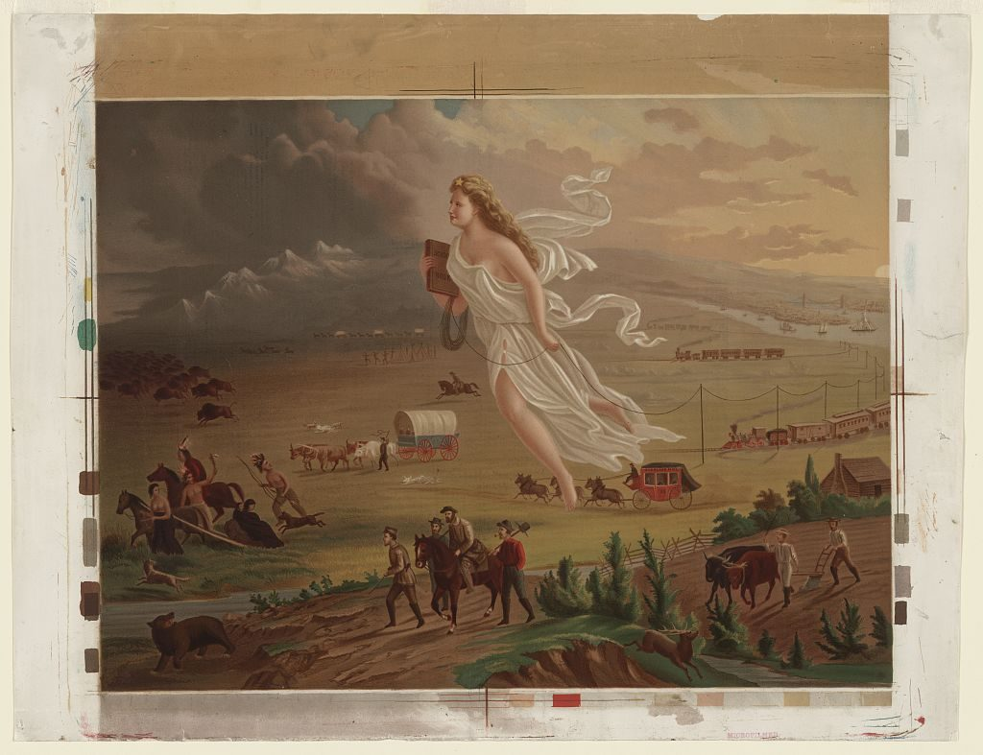
“American Progress” by John Gast, 1872 — a glowing figure of Columbia leads settlers, railroads, and telegraph wires west, as Native peoples and buffalo flee into the dark. Painting, public domain (Library of Congress).

THE SOURCES
THE CASE FOR THE WAR · PRESIDENT POLK, 1846
“Mexico has passed the boundary of the United States, has invaded our territory and shed American blood upon the American soil… As war exists, and notwithstanding all our efforts to avoid it, exists by the act of Mexico herself, we are called upon… to prosecute it with vigor.”
Polk’s war message to Congress.
THE IDEA BEHIND IT · JOHN O’SULLIVAN, 1845
“[It is] the fulfillment of our manifest destiny to overspread the continent allotted by Providence for the free development of our yearly multiplying millions.”
The phrase that named the age.
THE CASE AGAINST · REP. ABRAHAM LINCOLN, 1847
Lincoln demanded that Polk identify the exact “spot” of soil on which American blood had been shed, suspecting the skirmish had happened on Mexican, not American, land — which would make Polk’s whole justification false
Lincoln’s ‘Spot Resolutions’ challenge Polk’s story.
THE SOLDIER’S VERDICT · ULYSSES S. GRANT, 1885
“I do not think there was ever a more wicked war than that waged by the United States on Mexico. I thought so at the time, when I was a youngster, only I had not moral courage enough to resign.”
Looking back, decades later.

YOUR WORK
A. TWO OF THESE FOUR VOICES DEFEND THE WAR AND TWO CONDEMN IT. FOR EACH, WHAT WAS THE SPEAKER’S ROLE, AND HOW MIGHT THAT SHAPE WHAT HE SAYS?
a. Two of these four voices defend the war and two condemn it. For each, what was the speaker’s role, and how might that shape what he says?
____________________________________________________________________________________________
____________________________________________________________________________________________
____________________________________________________________________________________________
B. GRANT FOUGHT IN THE WAR BUT CONDEMNED IT FORTY YEARS LATER. DOES THAT MAKE HIS VERDICT MORE TRUSTWORTHY, OR LESS? EXPLAIN.
b. Grant fought in the war but condemned it forty years later. Does that make his verdict more trustworthy, or less? Explain.
____________________________________________________________________________________________
____________________________________________________________________________________________
____________________________________________________________________________________________
____________________________________________________________________________________________
A. POLK SAYS WAR “EXISTS BY THE ACT OF MEXICO HERSELF.” WHAT DOES THAT PHRASING LET AMERICANS BELIEVE ABOUT WHO STARTED IT — AND WHAT DOES IT LEAVE OUT?
a. Polk says war “exists by the act of Mexico herself.” What does that phrasing let Americans believe about who started it — and what does it leave out?
____________________________________________________________________________________________
____________________________________________________________________________________________
____________________________________________________________________________________________
____________________________________________________________________________________________
B. “MANIFEST DESTINY” MADE EXPANSION SOUND LIKE FATE RATHER THAN CHOICE. WHO BENEFITS WHEN TAKING LAND IS DESCRIBED AS DESTINY?
b. “Manifest Destiny” made expansion sound like fate rather than choice. Who benefits when taking land is described as destiny?
____________________________________________________________________________________________
____________________________________________________________________________________________
____________________________________________________________________________________________
____________________________________________________________________________________________
NAME ONE HARD FACT ABOUT THE WAR THAT BOTH THE DEFENDERS AND THE CRITICS WOULD HAVE TO ACCEPT — THEN ONE THING THEY FLATLY DISAGREE ABOUT. WHAT MAKES THE FIRST KIND OF CLAIM DIFFERENT FROM THE SECOND?
Name one hard fact about the war that both the defenders and the critics would have to accept — then one thing they flatly disagree about. What makes the first kind of claim different from the second?
____________________________________________________________________________________________
____________________________________________________________________________________________
____________________________________________________________________________________________
____________________________________________________________________________________________
CLAIM — WAS THE MEXICAN-AMERICAN WAR THE FULFILLMENT OF A NATIONAL DESTINY, OR AGGRESSION AGAINST A WEAKER NEIGHBOR? TAKE A CLEAR POSITION.
CLAIM — Was the Mexican-American War the fulfillment of a national destiny, or aggression against a weaker neighbor? Take a clear position.
____________________________________________________________________________________________
____________________________________________________________________________________________
____________________________________________________________________________________________
EVIDENCE — GIVE AT LEAST TWO SPECIFICS FROM THE PRESENTATION AND THE SOURCES ABOVE THAT SUPPORT YOUR CLAIM.
EVIDENCE — give at least two specifics from the presentation and the sources above that support your claim.
____________________________________________________________________________________________
____________________________________________________________________________________________
____________________________________________________________________________________________
____________________________________________________________________________________________
REASONING — YOU HAVE READ THIS WAR MOSTLY FROM THE AMERICAN SIDE. WHAT IS ONE QUESTION YOU WOULD NEED THE MEXICAN SIDE TO ANSWER BEFORE YOU WERE FULLY SURE OF YOUR VERDICT?
REASONING — you have read this war mostly from the American side. What is one question you would need the Mexican side to answer before you were fully sure of your verdict?
____________________________________________________________________________________________
____________________________________________________________________________________________
____________________________________________________________________________________________
____________________________________________________________________________________________
Promise & Practice · ShadowDog Digital Studios · Unit 2

TEACHER ANSWER KEY — Destiny or Aggression?

a. Two of these four voices defend the war and two condemn it. For each, what was the speaker’s role, and how might that shape what he says?: Open response.
b. Grant fought in the war but condemned it forty years later. Does that make his verdict more trustworthy, or less? Explain.: Open response.
a. Polk says war “exists by the act of Mexico herself.” What does that phrasing let Americans believe about who started it — and what does it leave out?: Open response.
b. “Manifest Destiny” made expansion sound like fate rather than choice. Who benefits when taking land is described as destiny?: Open response.
Name one hard fact about the war that both the defenders and the critics would have to accept — then one thing they flatly disagree about. What makes the first kind of claim different from the second?: Open response.
CLAIM — Was the Mexican-American War the fulfillment of a national destiny, or aggression against a weaker neighbor? Take a clear position.: Open response.
Look for a response along the lines of: “The war is best understood as… because…”
EVIDENCE — give at least two specifics from the presentation and the sources above that support your claim.: Open response.
REASONING — you have read this war mostly from the American side. What is one question you would need the Mexican side to answer before you were fully sure of your verdict?: Open response.

